# Problem1 Image Demosaicing and Histogram Manipulation

Motivation:

This probelm

## 1.a

All the size of the pictures are read from photo editor, and then built in to the code of each sub-question. But this is not good for potability, which means you may need to edit the code every time you change a picture.

I did not use bilinear demosaicing on all the pixels on the edges and corners, because they lack some adjacent pixels.

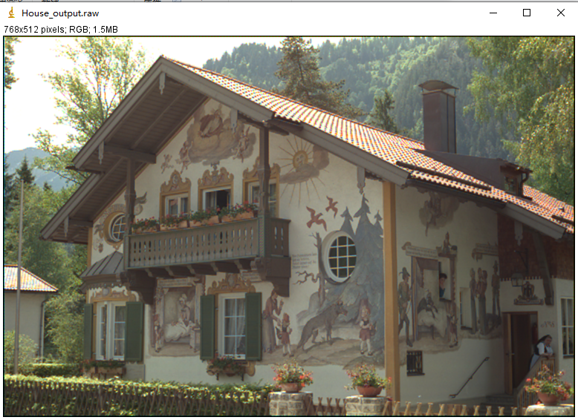

g++ -o test BilinearDemosaicing.cpp

test images/House.raw output/House_output.raw

cannot accomondate 2 768*512*3 pictures, must use dynamic allocation

应该是image[height][width][3]，像素一行一行填满

**1.b**

**1.b.1**

I output the intensity distribution data to a txt file, and then use python to plot.

The code is in HistogramMani1.cpp (part commented) and plot Histogram.py (part commented)

There seems some strips on the figure, where somewhere is dense and somewhere is sparse. But it is due to the plotting function, and has nothing to do with the image itself.

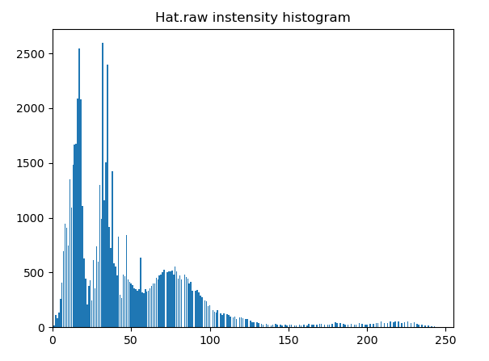

1.b.2

When doing the transfer function based histogram equalization and mapping original CDF to the new uniform CDF, I do floor rounding. That is, if Prob(x)*255 is not an integer, we round it down.

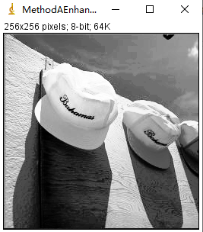

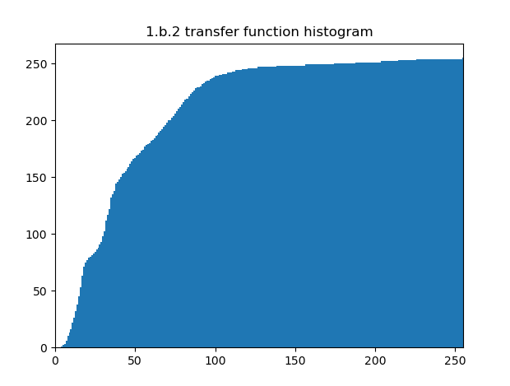

g++ -o HistogramMani1 HistogramMani1.cpp

HistogramMani1 images/Hat.raw

MethodAEnhanced.raw

1.b.3

When filling the buckets, pixels values are assigned sequentially, not randomly. But the difference will not be distinguishable to eyes.

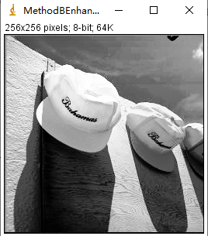

The original pixel intensity cumulative distribution seems like this

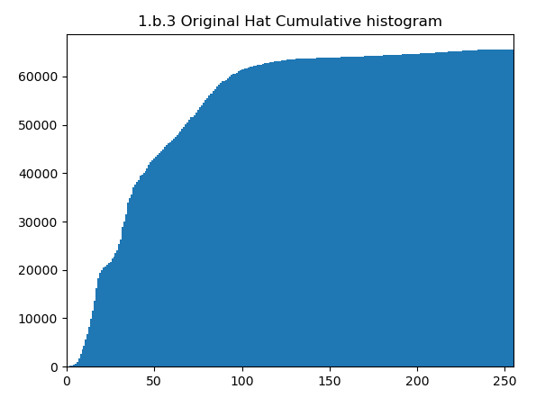

And after method B enhancement, it becomes exactly uniform.

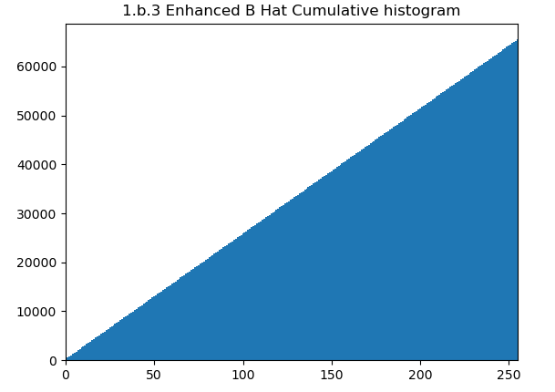

g++ -o HistogramMani2 HistogramMani2.cpp

HistogramMani2 images/Hat.raw

MethodBEnhanced.raw

1.b.4

Comparing the two method, I may suppose method B is better, or in other words, better at equalization. For method A manipulated images, there may be 512 pixels with intensity 0, 0 pixels in intensity 1 (be skipped). In contrast, method B manipulated images will have exactly same number of pixels in every intensity value.

1.c.1

CLAHE is an advanced edition of AHE. Adaptive histogram equalization does not enhance the global contrast anymore, it only enhance the local contrast like a 8*8 square by default. But if there is a relatively uniform area, it will also be forced to stretch to the whole intensity range, that will enhance the noise. CLAHE limit the local contrast, by setting a threshold for pixels to be equalized. To be intuitive, it only equalized those of pixels that exceed the threshold in the histogram. It is equivalent to limit the slope of transfer function, since the local slope is just the amount of pixel with specific intensity.

1.c.2.1

file.open(argv[1],ios::in | ios::binary );

file>>noskipws>>Imagedata[i][j][k]

when converting from YUV to RGB with the equations given, it may exceed the range [0,255]. For value <0 we turn it to 0, for >255, we turn it to 255.

g++ -o clahe CLAHE.cpp

clahe images/Taj_Mahal.raw output/TajMani1.raw

TajMani1.raw

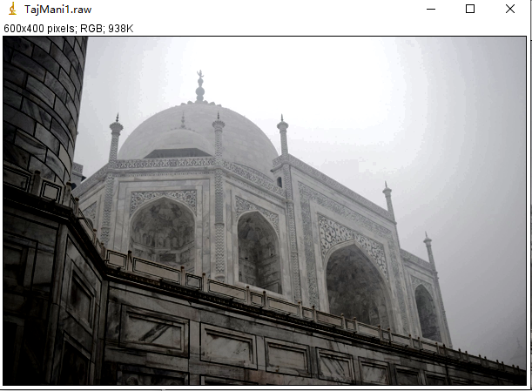

1.c.2.2

Since 240000 can not be divide into integer by 256, we round it to the nearest integer, and set it to be the numbers of pixels in each buckets. That maybe 937 or 938

>g++ -o clahe2 CLAHE2.cpp

clahe2 images/Taj_Mahal.raw output/TajMani2.raw

TajMani2.raw

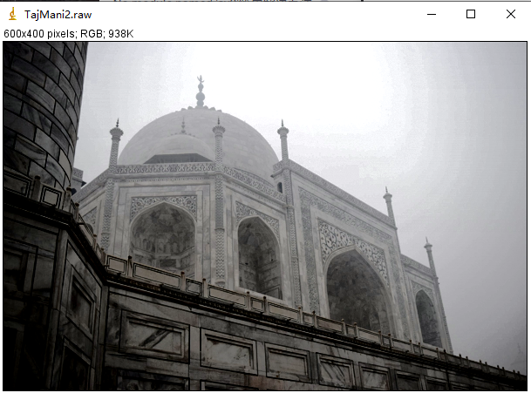

1.c.3

My g++ cannot find OpenCV library, so I can only run it in Clion.

After several attempt, I shall say the best cliplimit is between 2 and 3, so I set 2.5. And for the gridsize, the default value 8*8 seems the best.

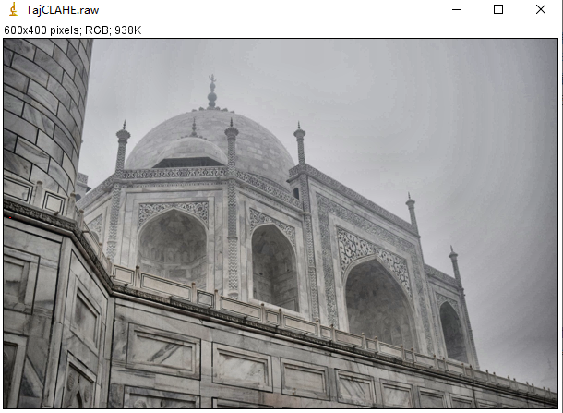

1.c.4

Comparing CLAHE and AHE, it’s obvious that CLAHE does better than AHE. In AHE-manipulated figures, there’re parts where it’s too dark or too bright, while CLAHE picture looks uniform and clear everywhere.

**Problem 2**

2.a.1

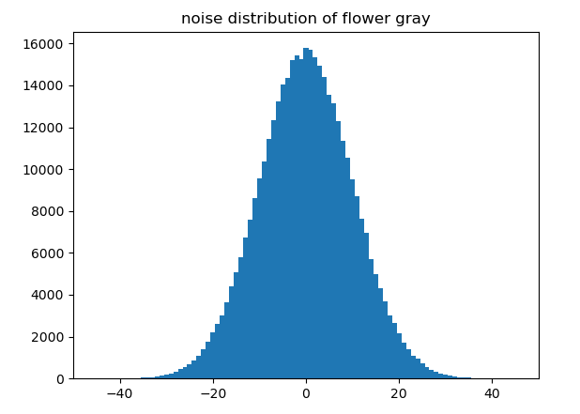

I use the noisy picture to substract source picture, and get the distribution of noise. It’s possibly gaussian. And in addition, when looking at the pixels, there’s no obvious salt noise or pepper noise, so I suppose there’s no impulse noise. The noise in *Flower_gray_noisy.raw* is gaussian

g++ -o ImageDeno ImageDeno.cpp

ImageDeno

Flower_gray_noise_Histo.txt

Process with Python plotHistogram.py

2.a.2

For all the filters, we round the modified value to the closest integer. And with regard to those pixels on the edge, which cannot be set as the center of a filter, we just leave them unchanged.

For mean filter, with 3*3 filter size, we got the following output with following command:

*g++ -o ImgDenoMean ImgDenoMean.cpp*

*ImgDenoMean images/Flower_gray_noisy.raw output/Flower_gray_DenoMean3.raw 3*

*Output(PSNR): 31.3409*

*Flower_gray_DenoMean3.raw*

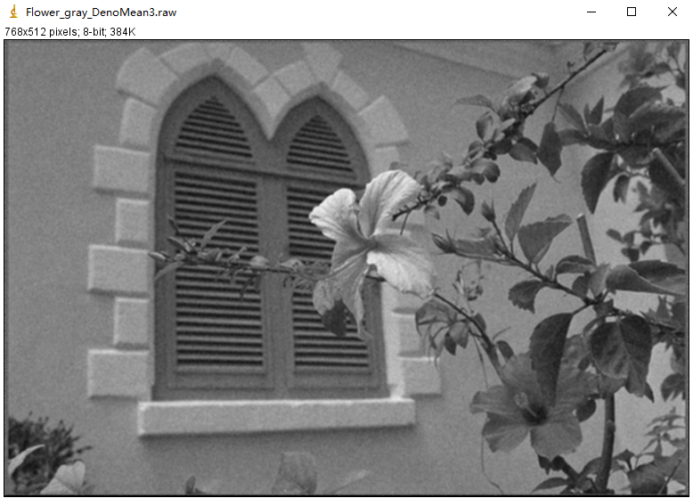

For mean filter, with 5*5 filter size, we got the following output with following command:

*g++ -o ImgDenoMean ImgDenoMean.cpp*

*ImgDenoMean images/Flower_gray_noisy.raw output/Flower_gray_DenoMean5.raw 5*

*Output(PSNR):* 28.1684

*Flower_gray_DenoMean5.raw*

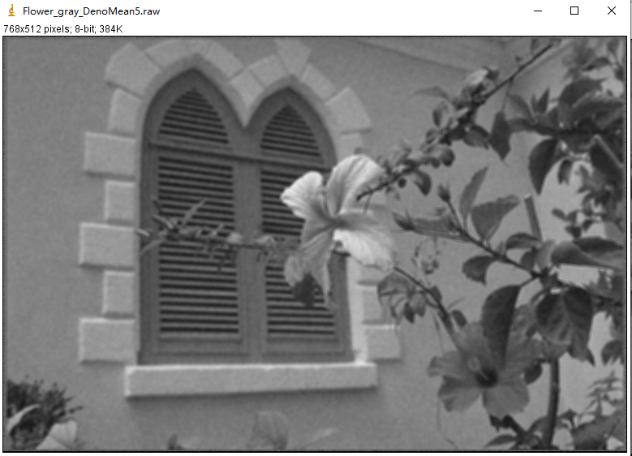

For the guassian filters, we assume the standard deviation is 1.

With 3*3 filter size, we got the following output with following command:

*g++ -o ImgDenoGauss ImgDenoGauss.cpp*

*ImgDenoGauss images/Flower_gray_noisy.raw output/Flower_gray_DenoGauss3.raw 3*

*Output(PSNR):* 32.426

*Flower_gray_DenoGauss3.raw*

This is the applied filter

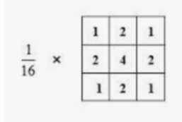

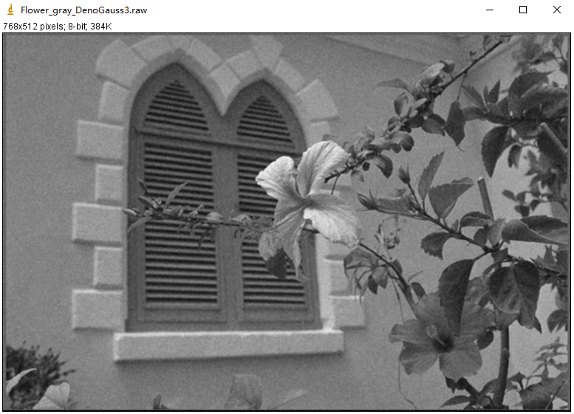

With 5*5 filter size, we got the following output with following command:

*g++ -o ImgDenoGauss ImgDenoGauss.cpp*

*ImgDenoGauss images/Flower_gray_noisy.raw output/Flower_gray_DenoGauss5.raw 5*

*Output(PSNR):* 31.1134

*Flower_gray_DenoGauss5.raw*

This is the applied filter

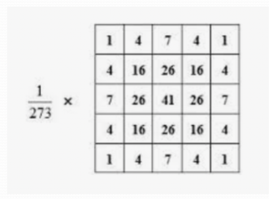

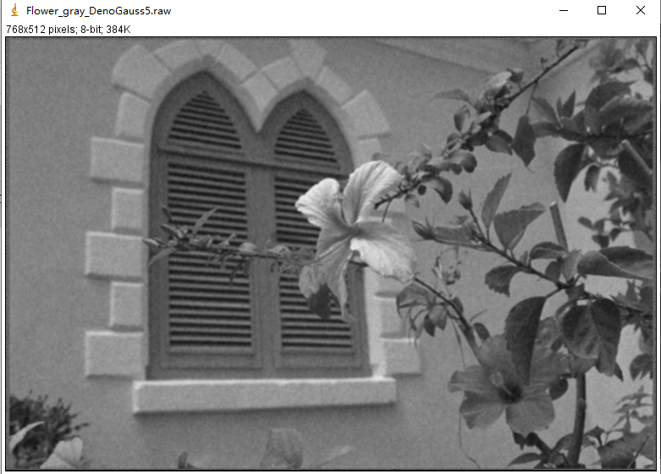

Based on the PSNR, we can see at same filter size, gaussian filter has better performance than mean filter, and with same filter type, 3*3 size has better performance than 5*5.

Based on visual inspection, I would also say mean filter will make the image blurrier than Gaussian. The edges are not clear any more. So overall, Gaussian filter performs better.

2.b.1

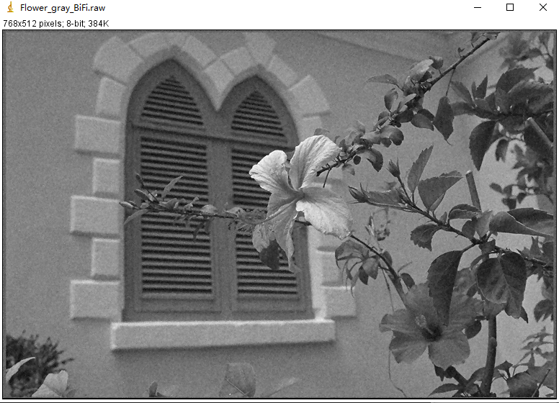

This is a bilaterally filtered output with kernel size 3*3 and σ­c=1, σs=20

*g++ -o BilateralFilter BilateralFilter.cpp*

*BilateralFilter images/Flower_gray_noisy.raw output/Flower_gray_BiFi.raw 3*

*Output(PSNR):* 32.659

*Flower_gray_BiFi.raw 3*

The σ­c/σs can only be adjusted within the code blocks.

If we use 5*5 kernel, with same sigma tuning, the PSNR is 32.9485, no significant difference.

2.b.2

σ­c determine the weight according to spatial distance, and σ­s determines the weight according to intensity difference. The larger σ­c is, the more weight a distant pixel will get. Similarly, the larger σ­s is, the more weight a pixel with non-similar intensity will get. In addition, because the two gaussian distribution are timed together, so if one goes to zero, the whole term vanish. Therefore both parameter should be properly set.

To investigate the influence of σ­c and σs, we use the 3*3 kernel and test on different value combination.

|  |  |  |  |  |
| --- | --- | --- | --- | --- |
| σ­c/σs PSNR | 20 | 30 | 40 | 50 |
| 1 | 32.659 | 33.5743 | 33.7102 | 33.5943 |
| 2 | 33.0841 | 33.7361 | 33.6515 | 33.3809 |
| 4 | 33.1446 | 33.7241 | 33.5897 | 33.2867 |

The best parameter for this picture we can achieve might be around σ­c=2, σs=30.

2.b.3

We can see in most cases, when parameters are properly tuned, the performance of bilateral filter is slightly better than 3*3 size gaussian filter, and is also better than mean filter.

2.c.1

There’s two in four parameters mentioned by HW instructions that can be tuned by Opencv, the small neighbor window size and the large search window size. Also, there’s an additional parameter h indicating filter strength. According to OpenCV documents, “big h value perfectly removes noise but also removes image details, smaller h value preserves details but also preserves some noise”.

This is run with parameter h=10, small window=7, big window=21. The two window sizes are default values. PNSR=34.289

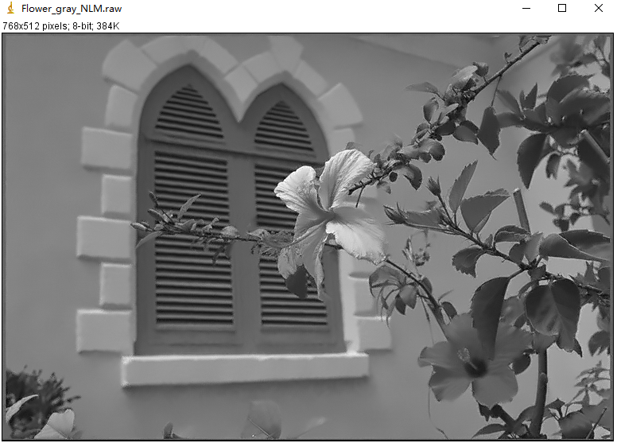

The program can only be run directly in Clion, so no sample command. The parameters are also tuned within code blocks.

To find the best parameter combination, I first look for proper h.

|  |  |  |  |  |  |  |  |
| --- | --- | --- | --- | --- | --- | --- | --- |
| h | 3(default) | 5 | 7 | 10 | 12 | 15 | 20 |
| PSNR | 28.1249 | 28.45 | 31.6954 | 34.289 | 34.2068 | 32.8919 | 30.4811 |

So we let h=10.

Then we try to find best window size

|  |  |  |  |  |
| --- | --- | --- | --- | --- |
| Neighbor/search | 11 | 21 | 31 | 41 |
| 3 | 34.2497 | 34.7967 | 34.7661 | 34.6865 |
| 5 | 34.3215 | 34.7775 | 34.6901 | 34.5648 |
| 7(default) | 33.9902 | 34.289 | 34.1523 | 34.0106 |
| 9 | 33.6833 | 33.8773 | 33.7088 | 33.551 |

So the best neighbor window/search window size is (3*3, 21*21)

To theoretically analyze h and a (this h is supposed to be different with OpenCV h, but maybe they are corelated), larger a will give more weight to distant pixels within a neighbor window, while larger h will give more weight to non-similar neighbor blocks.

2.c.2

NLM output has slightly higher PSNR, and it seems much more finer and smoother than previous output, especially the wall. You can hardly see any noises on it. But on the other hand, it may have lose some details, and make it kind of unreal.

2.d.1

I first capture the noise distribution of three color channel by subtracting the noisy image with the original image.

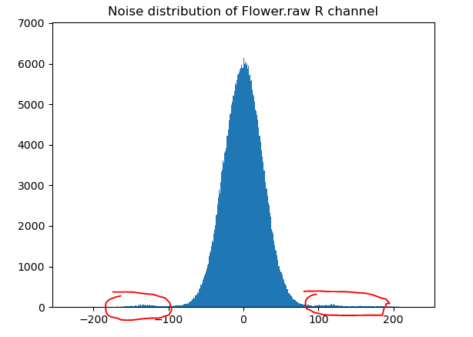

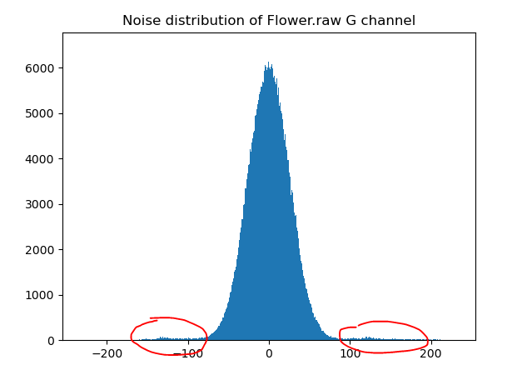

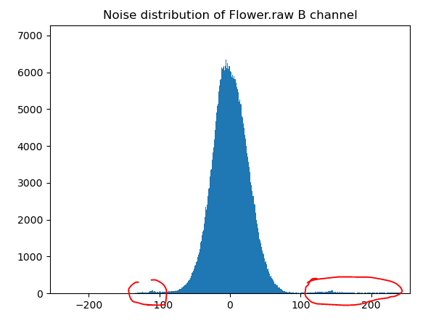

While majority of the noise follows the Gaussian distribution, there’s tiny amount of noise who has huge intensity locate on two sides of the main peak. They are possibly impulse noise. The rest majority are gaussian noise.

2.d.2

We would deal with impulse noise first, because impulse noise are easy to recognized (intensity difference between source image and noisy image goes beyond a threshold). If impulse filter is applied after gaussian noise filter, the bad impulses would already have done unnecessary impact on other good pixels, and the impulses themselves would also be reduced, letting it harder to recognize in the second round.

To deal with impulse noise, I would choose median filter. Basically we have two choice, mean filter and median filter. The reason why median filter is better than mean in terms of impulse removal is that, median value is not sensitive to one or two unusual values. That is to say it can remove salts or peppers without afftecting surrounding good pixels, while mean filter cannot do that.

To deal with Gaussian noise, I would use NLM filter as long as the resource consumption is acceptable, since it has the best performance.

2.d.3

(1) Methods and results

My final method is use a 5*5 median filter first, then apply NLM.

For the median filter, I find out that the best size is 5*5, and the best threshold for abs(Noisy[i][j][k]-Src[i][j][k]) is 10. All pixels that has greater difference than this threshold would undergo the median filter. In addition, because the noise in this picture is huge and dense, I have to set another threshold, that those heavily polluted pixels will not join the calculation of neighborhood median. The setting for “heavily polluted pixels” is having noise intensity greater or equal to 20.

Then I applied NLM with OpenCV *fastNlMeansDenoisingColored()* function. However I did not see any improvement by adjusting its parameter, so I just refer to the default values as well as the best practical value found in previous parts.

The final output is shown below.

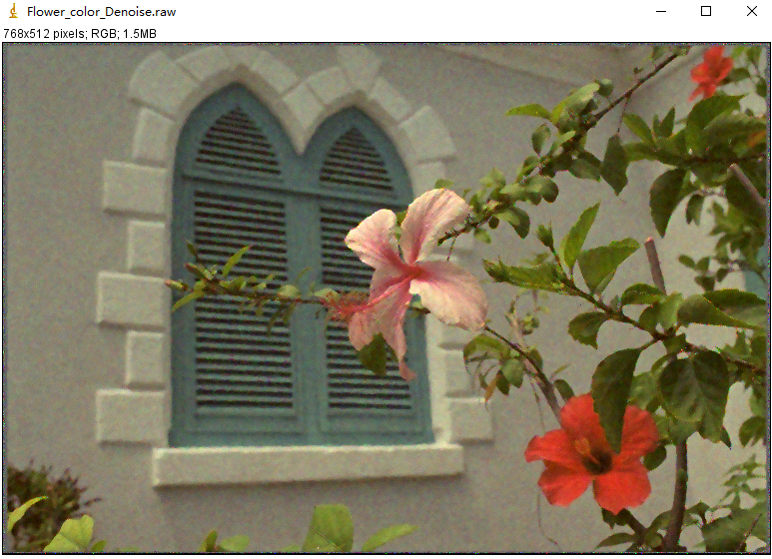

(2) Shortcomings

Compare with the noisy image, the algorithm succeeds in removing the impulse. However, we can still see the color on the wall is not uniform. I tried many methods like introducing another Gaussian filter trying to smoothen the wall, but they didn’t work. And there’re actually a few singular pixels on the edges of some leaves.

(3) Possible improvements

The noise in this colored image may be too heavy to be removed by linear and non-linear filters. But still, I think there’ll possibility that the wall can be processed better through learning method. Because it’s a large continuous area, and the color varies a little. Maybe we can try to find out the boundary of the walls, and then somehow ‘dye’ it smoothly.

Problem 3

3.1

For size 5 frosted glass filter,

*g++ -o FrostedGlassFilter FrostedGlassFilter.cpp*

*FrostedGlassFilter images/Flower.raw output/Flower_Frosted_5.raw 3 5*

*Output: Flower_Frosted_5.raw*

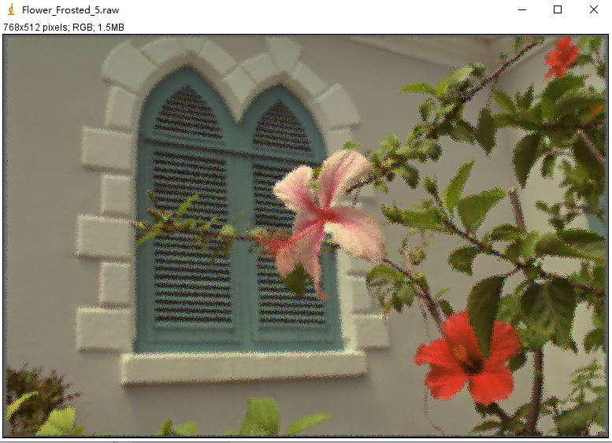

For size 7 frosted glass filter,

*g++ -o FrostedGlassFilter FrostedGlassFilter.cpp*

*FrostedGlassFilter images/Flower.raw output/Flower_Frosted_7.raw 3 7*

*Output: Flower_Frosted_7.raw*

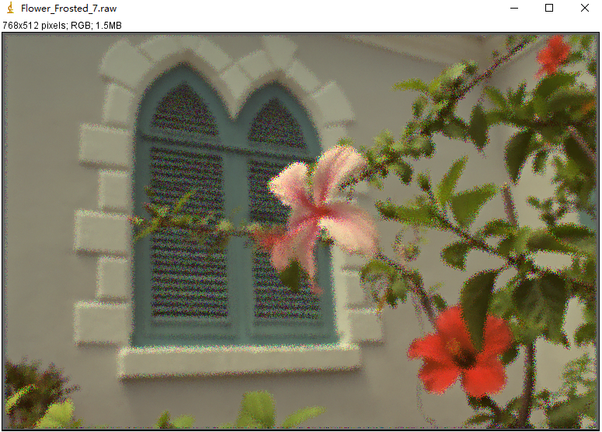

3.2

*FrostedGlassFilter images/Flower_noisy.raw output/Flower_noisy_Frosted_5.raw 3 5*

*Output: Flower_noisy_Frosted_5.raw*

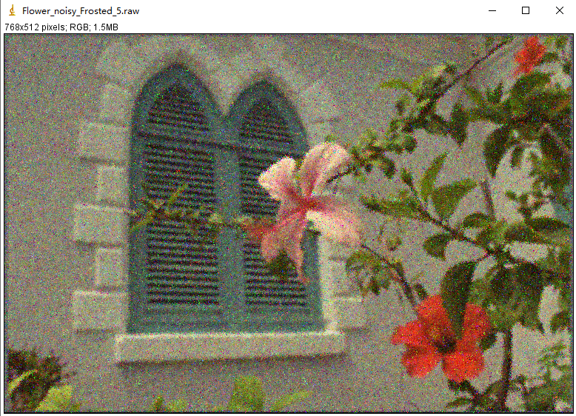

*FrostedGlassFilter images/Flower_noisy.raw output/Flower_noisy_Frosted_7.raw 3 7*

*Output: Flower_noisy_Frosted_7.raw*

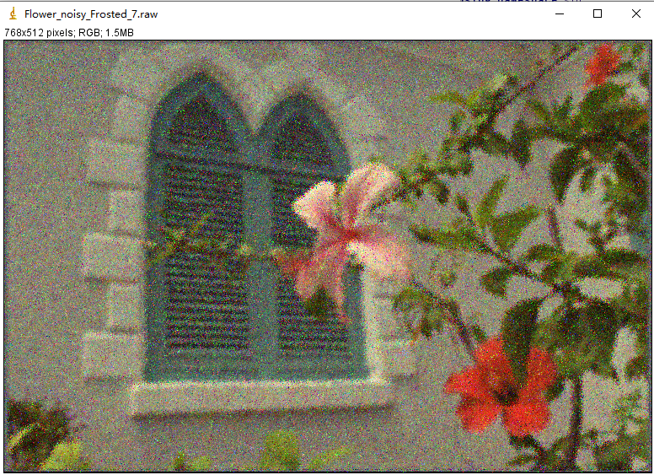

I don’t think the noise leads to any significant change. It seems as noisy as before.

If use gaussian denoise first then forsted,

*FrostedGlassFilter output/Flower_gray_DenoGauss5.raw output/Flower_gray_noisy_DenoFro_5.raw 1 5*

*Output: Flower_gray_noisy_DenoFro_5.raw*

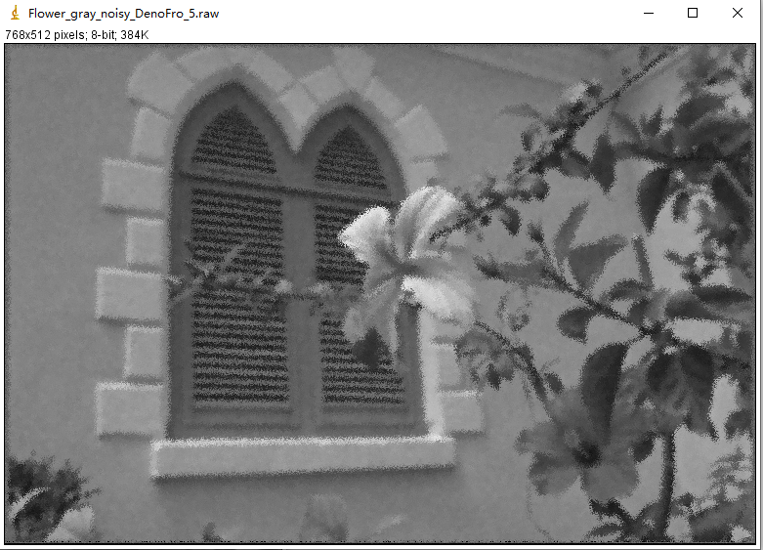

If we first frosted then denoise:(use 5*5 filter in both step)

*FrostedGlassFilter images/Flower_gray_noisy.raw output/Flower_gray_noisy_Frosted_5.raw 1 5*

*Output: Flower_gray_noisy_Frosted_5.raw*

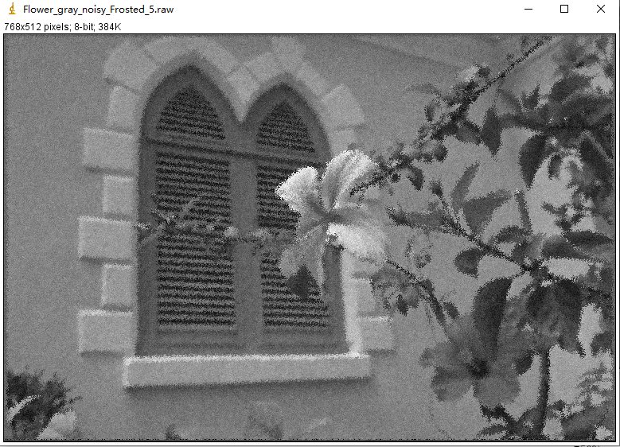

*ImgDenoGauss output/Flower_gray_noisy_Frosted_5.raw output/Flower_gray_FroDeno_5.raw 5*

*Output: Flower_gray_FroDeno_5.raw*

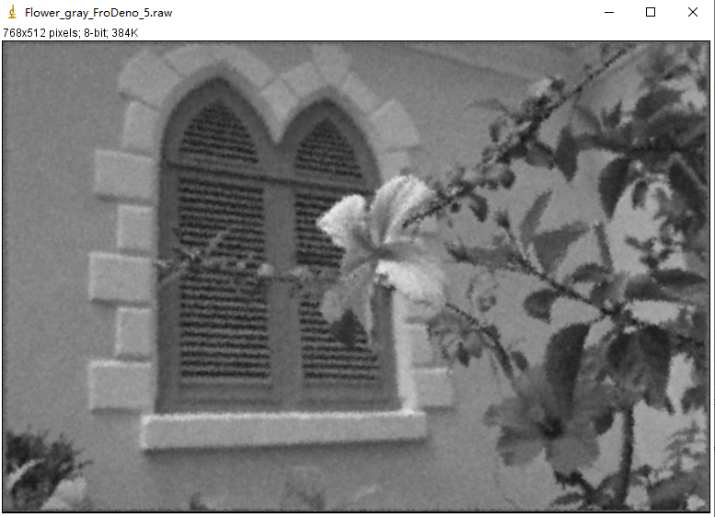

For process A (first denoise then apply forsted filter), The additional frosted filter makes smooth area, like the wall, even smoother than when only gaussian filter is applied. But the boundaries like the flower, leaves and window-shade become very ugly.

For process B (first frosted filter then denoise), I think the overall frosted effect seems more uniform than process A.